Issue: if we are not getting the assertThat() auto suggestion in eclipse then set the following settings:

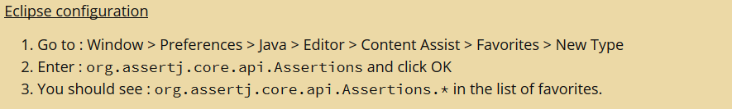

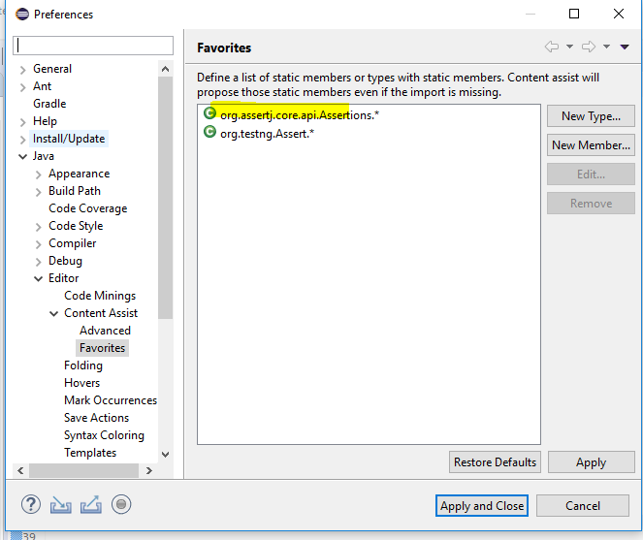

In our project, we are using AssertJ libarary instead of testng assertion due to following advance assertion validation.

